**AIRLINE RESERVATION**

**A Minor Project Report**

**Submitted in Partial fulfillment for the award of**

**Bachelor of Engineering in Computer Science & Engineering**

Submitted to

**RAJIV GANDHI PROUDYOGIKI VISHWAVIDYALAYA**

**BHOPAL (M.P)**



**MINOR PROJECT REPORT**

Submitted by

ANUPAM HALDKAR(30)ABHISHEK SINGH(10)

ADARSH SABLE(12) ISHAN JOSHI(64)

Under the supervision of

HITESH GUPTA ASST.PROFFESOR(CSE)

RATNESH DUBEY ASST. PROFFESOR(CSE)



**Department of Computer Science & Engineering**

**Lakshmi Narain College of Technology, Bhopal (M.P.)**

**Session 2018-19**



LAKSHMI NARAIN COLLEGE OF TECHNOLOGY, BHOPAL

**DEPARTMENT OF COMPUTER SCIENCE & ENGINEERING**

* + 1. **CERTIFICATE**

This is to certify that the work embodied in this project work entitled **”AIRLINE RESERVATION”** has been satisfactorily completed by the **ANUPAM HALDKAR(**30**)**, **ADARSH SABLE** (12) , **ABHISHEK SINGH** (10) , **ISHAN JOSHI** (64). It is a bonafide piece of work, carried out under the guidance in **Department of Computer Science & Engineering**, **Lakshmi Narain College of Technology, Bhopal** for the partial fulfillment of the **Bachelor of Engineering** during the academic year 2018-19.

**Guided By**

* 1. HITESH GUPTA ASST. PROFFESOR(CSE)

1. RATNESH DUBEY ASST. PROFFESOR(CSE)

**Approved By**

**SADHNA K MISHRA**

**Prof. & Head**

1. **Department of Computer Science & Engineering**



LAKSHMI NARAIN COLLEGE OF TECHNOLOGY, BHOPAL

**DEPARTMENT OF COMPUTER SCIENCE & ENGINEERING**

**ACKNOWLEDGEMENT**

We express our deep sense of gratitude to Prof. HITESH GUPTA RATNESH DUBEY(Guide) department of Computer Science & Engineering L.N.C.T., Bhopal. Whose kindness valuable guidance and timely help encouraged me to complete this project.

A special thank goes to Dr. Sadhna K. Mishra (HOD) who helped me in completing this project work. She exchanged her interesting ideas & thoughts which made this project work successful.

We would also thank our institution and all the faculty members without whom this project work would have been a distant reality.

ISHAN JOSHI(64)

ADARSH SABLE(12)

ABHISHEK SINGH(10)

ANUPAM HALDKAR(30)

INDEX

|  |  |  |
| --- | --- | --- |
| **S.NO.** | **TOPICS** | **PAGES** |
|  | Problem Domain | 5-6 |
|  | Literature Survey | 7-8 |
|  | Major objective & scope of project. | 9 |
|  | Problem Analysis and requirement specification | 10-12 |
|  | Detailed Design(Modeling and ERD/DFD ) | 13-18 |
|  | Hardware/Software platform environment | 19-20 |
|  | Snapshots of Input & Output | 21-24 |
|  | Coding () | 25-38 |
|  | Project limitation and Future scope | 39-40 |
|  | References | 41 |

**CHAPTER 1**

PROBLEM DOMAIN



PROBLEM DEFINITION

1.1 Existing System

In few countries if a person wants to book a flight ticket, he use to follow one of these

things:

* Manually goes to the Airport and book his ticket.
* Downloading the ticket form as paper document, filling it manually and

submitting it at Airport.

* Fill the Ticket form on system and get the print out as paper documents to submit

it at Airport.

* Booking the Ticket at some particular registered ticket counters in online.
* Even above approaches make a ticket booking online, it was not completely done

on online. Passenger may not have much freedom over this approach.

* Hence the Passenger may or may not be satisfied with this approach as it includes

manual intervention like travelling to Airport for booking his ticket.

* No use of Web Services and Remoting.
* No proper coordination between different Applications and Users.
* Fewer Users – Friendly

1.2 Proposed System:

The Proposed system ensures the complete freedom for users, where user at his own

system can logon to this website and can book his ticket. Our proposed system allows

only registered users to book the tickets, view booked tickets and cancel their tickets.

In this Proposal the entire work is done on online and ticket with id (PNR No.)

provided for passengers.

Advantages:

* User friendliness provided in the application with various controls.
* The system makes the overall project management much easier and flexible.

1.3 Product Functions

The website will allow access only to authorized users with specific roles

(Administrator- maintains the website, Company-Register the passengers, Passenger-

Fills the details).

Following are the System Functions:

**Passenger role:**

On the register form, passenger should enter all their detail such as their name, passport

number, Email and contact number.

**Administration role**

The system administrator must be able to: add, update and modify flights and view the

customer details.

1.4User Characteristics

**End Users**

All specific knowledge or skills are required from the feeder.

1. Educational level: Users should be comfortable with the English language.
2. Experience: Users should have prior information regarding the online booking.
3. Skills: Users should have basic knowledge and should be comfortable

**Administrator**

This system will not take care of any virus problem, which might occur either on the

Client or the server system. Avoiding the use of pirated software and ensuring that

floppies and other removable media are scanned for viruses before use could minimize

the possibility of viral infection

**CHAPTER 2**

LITERATURE SURVEY



Preliminary investigation examines project feasibility. The likelihood the system will be

useful to the organization. The main objective of the feasibility study is to test the

Technical, Operational and Economical feasibility for adding new modules and

debugging old running system. All system is feasible if they are unlimited resources and

infinite time. There are aspects in the feasibility study portion of the preliminary

investigation:

* Technical Feasibility
* Operation Feasibility
* Economic Feasibility

2.1 Technical Feasibility

The technical issue usually raised during the feasibility stage of the investigation

includes the following

* Does the necessary technology exist to do what is suggested?
* Does the proposed equipment have the technical capacity to hold the data
* required to use the new system?
* Are there technical guarantees of accuracy, reliability, ease of access and data

security?

Earlier no system existed to cater to the needs of ‘Secure Infrastructure

Implementation System’. The current system developed is technically feasible. It is a

17 web based user interface for audit workflow at NIC-CSD. Thus, it provides an easy

access to the users.

The database’s purpose is to create, establish and maintain a workflow among

various entities to facilitate all concerned users in their various capacities or roles.

Permission to the users would be granted based on the roles specified. Therefore, it

provides the technical guarantee of accuracy, reliability and security.

2.2 Operation Feasibility

Proposed projects are beneficial only if they can be turned out into information system.

That will meet the organization’s operating requirements. Operational feasibility aspects

of the project are to be taken as an important part of the project implementation. Some of

the important issues raised are to test the operational feasibility of a project includes the

following:

* Is there sufficient support for the management from the users?
* Will the system be used and work properly if it is being developed and
* implemented?
* Will there be any resistance from the user that will undermine the possible
* application benefits?

This system is targeted to be in accordance with the above-mentioned issues.

Beforehand, the management issues and user requirements have been taken into

18 consideration. So, there is no question of resistance from the users that can undermine

the possible application benefits.

2.3 Economic Feasibility

A system can be developed technically and that will be used if installed must still be a

good investment for the organization. In the economic feasibility, the development cost

in creating the system is evaluated against the ultimate benefit derived from the new

systems. Financial benefits must equal or exceed the costs.

**CHAPTER 3**

MAJOR OBJECTIVE AND SCOPE OF PROJECT



Airline Reservation System contains the details about flight schedules and its fare tariffs,

passenger reservations and ticket records. Air Alliance operates flights to 30 destinations

in India namely Allahabad, Bengaluru, Bhopal, Bhuj , Dehradun, Delhi, Diu,

Gorakhpur, Guwahati, Hyderabad, Jabalpur, Jaipur, Jammu, Kanpur, Kochi, Kolkata,

Kullu, Mumbai, Pantnagar, Pune, Raipur, Ranchi, Shimla, Surat, Vijayawada, Tezpur

and Tirupati.

The Airline Reservation System project is an implementation of a general Airline

Ticketing website like Orbitz, which helps the customers to search the availability and

prices of various airline tickets, along with the different packages available with the

reservations.

This project also covers various features like online registration of the users,

modifying the details of the website by the management staff or administrator of the

website, by adding, deleting or modifying the customer details, flights or packages

information. In general, this website would be designed to perform like any other airline

ticketing website available online.

The Online Airline Reservation system is the next generation address book which will

provide these two basic services like portability, security.

The scope includes expand the technologies like HTML and PHP we can

also add new technologies like HTML, php many more for improving the efficiency of

the software.

The project will be useful for any schools and colleges with slightly modification.

Project is flexible i.e. any change /modification in database may be performing easily.

Also this project could be made web enabled.

**Dependencies:**

The system should work on all systems.

**CHAPTER 4**

PROBLEM ANALYSIS AND SPECIFICATION REQUIREMENT



4.1 Problem Analysis

Problem/System Analysis is a detailed study of the various operations performed by a system and

their relationships within and outside of the system. Here the key question is- what all

problems exist in the present system? What must be done to solve the problem? Analysis

begins when a user or manager begins a study of the program using existing system.

4.2 Software Requirement Specification (SRS)

The software, Site Explorer is designed for management of web sites from a remote

location. This section provides software requirements to a level of detail sufficient to

enable designers to design the system an testers to test the system.

This section contains all of the functional and quality requirements of the system.

It gives a detailed description of the system and all its features.

4.2.1 Introduction

**Purpose:** The main purpose for preparing this document is to give a general insight into

the analysis and requirements of the existing system or situation and for determining the

operating characteristics of the system.

**Scope:** This Document plays a vital role in the development life cycle (SDLC) and it

describes the complete requirement of the system. It is meant for use by the developers

and will be the basic during testing phase. Any changes made to the requirements in the

future will have to go through formal change approval process.

4.2.2 Developer’s responsibilities overview:

The developer is responsible for:

* Developing the system, which meets the SRS and solving all the requirements of
* the system?
* Demonstrating the system and installing the system at client's location after the
* acceptance testing is successful.
* Submitting the required user manual describing the system interfaces to work on
* it and also the documents of the system.
* Conducting any user training that might be needed for using the system.
* Maintaining the system for a period of one year after installation.

The HTTP protocol will be used to facilitate communications between the client and

server. The system supports Google Chrome and Mozilla Firefox web browsers.

4.3. Memory Constraints

Minimum memory of 512MB is required to run the exe file without any lags. This

constraint does not possess an issue now a days as the minimum present RAM in a

common system is 1GB.

At least 512 MB RAM and 5 MB space on hard disk will be required for running

the program.

4.4. Operations

The normal and special operations required by the user such as:

* The various modes of operations in the user organization
* Periods of interactive operations and periods of unattended operations
* Data processing support functions
* Backup and recovery operations

4.5. Site Adaptation Requirements

There should no site adaptation requirement since the Web Application Server was setup.

4.6. Functional Requirements

* It deals with the functionalities required from the system which are as follows:
* The website will help the colleges/organizations/companies to conduct their
* student registration
* Only authorized person can access related details.
* Organizations can change their information regarding themselves. The students

can login through TEST-ID and PASSWORD.

* Administrator will be responsible for updating the site.

4.7 System Design

The purpose of System Design is to create a technical solution. That satisfies the

functional requirements for the system. At this Point in the project lifecycle there should

be a Functional Specification, written primarily in business terminology, containing a

complete description of the operational needs of the various organizational entities that

will use the new system.

The Challenge is to translate all of this information into Technical Specifications

that accurately describe the design of the system, And that can be used as input to

System Construction. Thee Functional Specification produced during System

Requirements Analysis is transformed into a physical architecture. System components

are distributed across the physical architecture, usable interfaces are designed and

prototyped, and

Technical Specifications are created for the Application Developers, enabling

them to build and test the system. Many organizations look at System Design primarily

as the Preparation of the system component specifications; however, Constructing the

various system components is only one of a setoff major steps in successfully building a

system.

The preparation of the environment needed to build the system, the testing of the

system, and the migration and preparation of the data that will ultimately be used by the

system are equally important.

In addition to designing the technical solution, System Design is the time to

initiate focused planning efforts for both the testing and data preparation activities.

**CHAPTER 5**

DETAILED DESIGN(MODELING AND ERD/DFD )



5.1 Data Flow Diagram

Four simple notations are used to complete a DFD. These notations are given below:-

Data Flow**: -**

The data flow is used to describe the movement of information from

one part of the system to another part.Data flow is represented by an arrow.

Process**: -**

A circle or bubble represents a process that transforms incoming data to

outgoing data. Process shows a part of the system that transform inputs to outputs.

External entity: -

External entities represent any entity that supplies or receive

information from the system but is not a part of the system.

Data store: -

The data store represents a logical file. A logical file can represent

either a data store symbol which can represent either a data structure or a physical file on

disk. The data store is used to collect data at rest or a temporary repository of data. It is

represented by open rectangle.

Output:-

The output symbol is used when a hard copy is produced and the user of the

copies cannot be clearly specified or there are several users of the output.

5.1.1: Context Diagram

Level-0:-

View customer info Reservation Form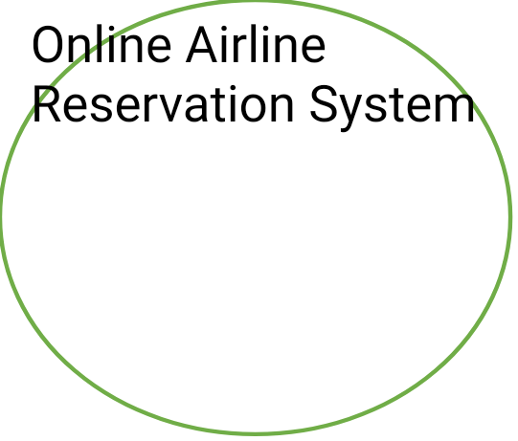





Fill detailsBook ticket

Level-1 DFD:-

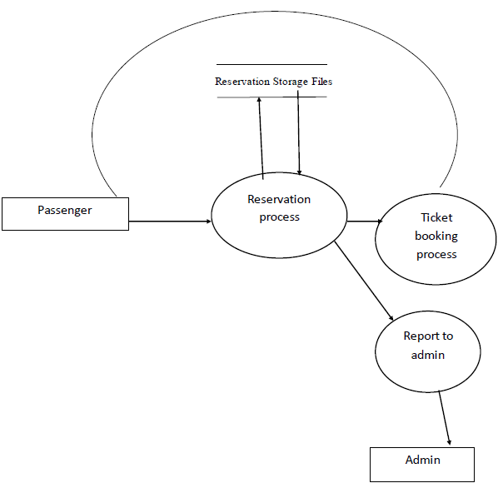

Level-2 DFD:-

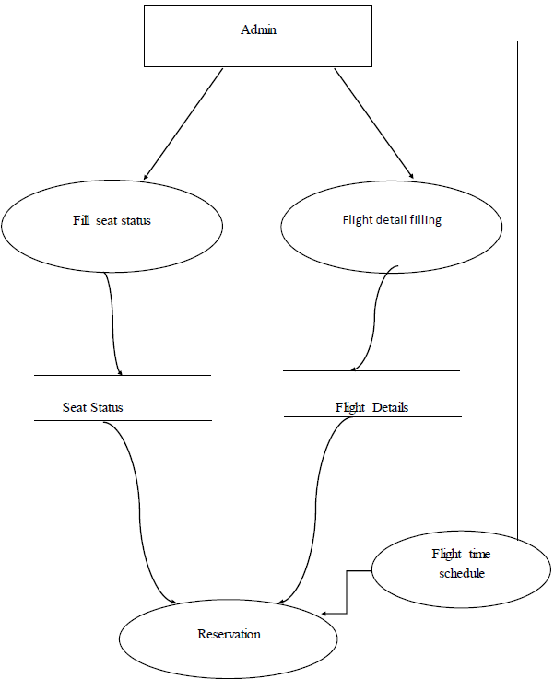

5.1.2: Use Case Diagram:-

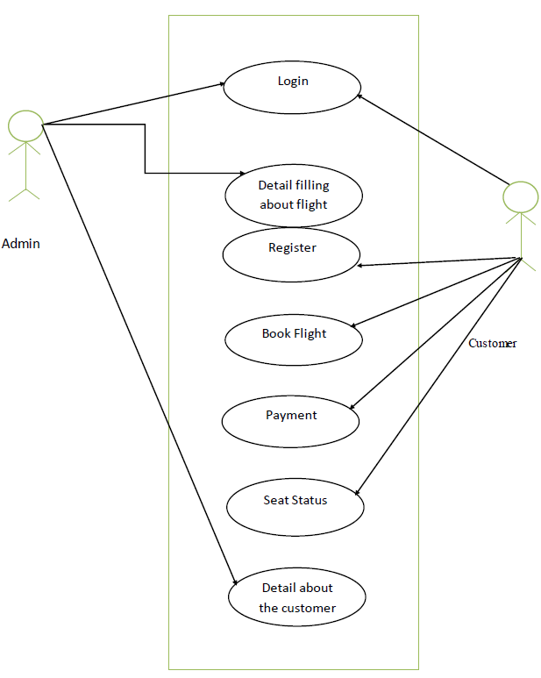

5.1.3: E-R Diagram:-

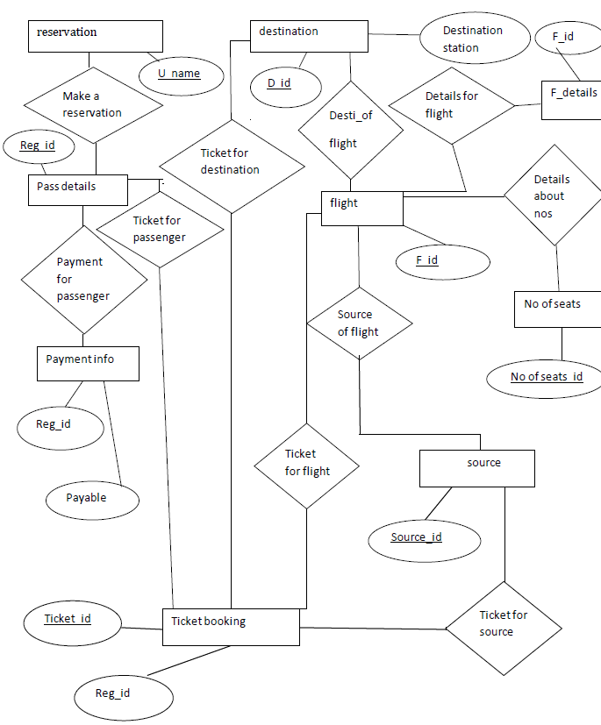

5.2: System Design

The list of modules incorporated with “AIRLINE RESERVATION SYSTEM “is as

follows:

5.2.1 Registration module

After registering with us the passenger can logon to his/her own account and can view

all flight details such as Timings, Prices, Availability of seats and can book the ticket

with unique ticket id and gives its personal details. Once Passenger registered with us

can book any number of tickets.

5.2.2 Administrative module

Administrative module is provided for the sake of administrators to manage the site and

update the content at regular intervals, the major operations included in this module are:

1. Create and maintain airline schedule, fare and timings of the Flight.
2. View the passenger list.
3. View booked tickets.
4. Add Aircraft Details.
5. Activate and Deactivate Aircraft.
6. View the available seats in the flights.
7. Modify the flight schedule and timings and fare.

5.2.3 Passenger module

This module is meant for passengers, where a user logging into his/her owns account will

view this panel. The major operations included in this module were

1. View all airline schedules, timings, fare details and seats availability.
2. Book for the tickets.
3. View the ticket.
4. Cancel ticket.

**CHAPTER 6**

HARDWARE/SOFTWARE PLATFORM ENVIRONMENT



6.1 Hardware Requirements:

* Intel I3 2.8 GHz Processor and Above
* RAM 1 GB and Above
* HDD 20 GB Hard Disk Space and Above

6.2 Software Requirements:

* WINDOWS OS (Windows 7, 8 ,10) Or Linux
* Sublime text editor,Visual studio Code
* PHP Server For Windows(Xampp)
* Database Mysql For Backend.

Server side –

An Xampp/Apache Web server will accept all requests from the client. A development

database will be hosted locally (using MySQL); the production database is hosted centrally.

MY-SQL (BACKEND)

MySQL is the world's most widely used RDBMS, and the most

widely used open-source client server model RDBMS. It is named after cofounder

Michael Widenius's. The SQL abbreviation stands for Structured Query

Language. The MySQL development project has made its source code available under

the terms of the GNU General Public License, as well as under a variety

of proprietary agreements.

Apache

The Apache HTTP Server is web server software notable for playing a key role in the

initial growth of the World Wide Web. In 2009 it became the first web server software to

surpass the 100 million web site milestone. Apache is developed and maintained by an

open community of developers under the auspices of the Apache Software Foundation.

Since April 1996 Apache has been the most popular HTTP server software in use.

XAMPP

XAMPP is a small and light Apache distribution containing the most common web

development technologies in a single package. Its contents, small size, and portability

make it the ideal tool for students developing and testing applications in PHP and

MySQL. XAMPP is available as a free download in two specific packages: full and lite.

While the full package download provides a wide array of development tools, XAMPP

Lite contains the necessary technologies that meet the Ontario Skills Competition

standard.

Sublime Text

It is a proprietary cross-platform source code editor with a Python application programming interface (API). It natively supports many programming languages and markup languages, and functions can be added by users with plugins, typically community-built and maintained under free-software licenses.

**CHAPTER 7**

SNAPSHOTS OF INPUT & OUTPUT



7.1 Login Form:

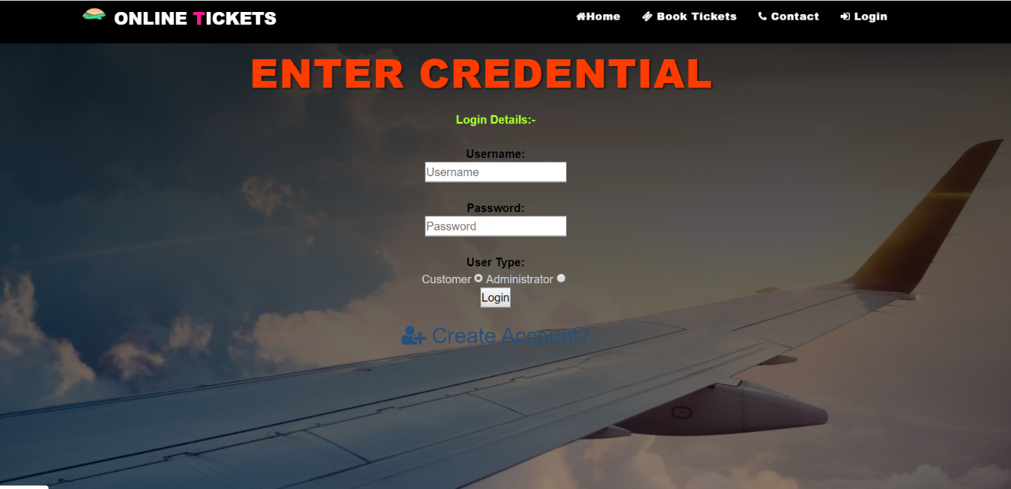

7.2 View Booked Tickets

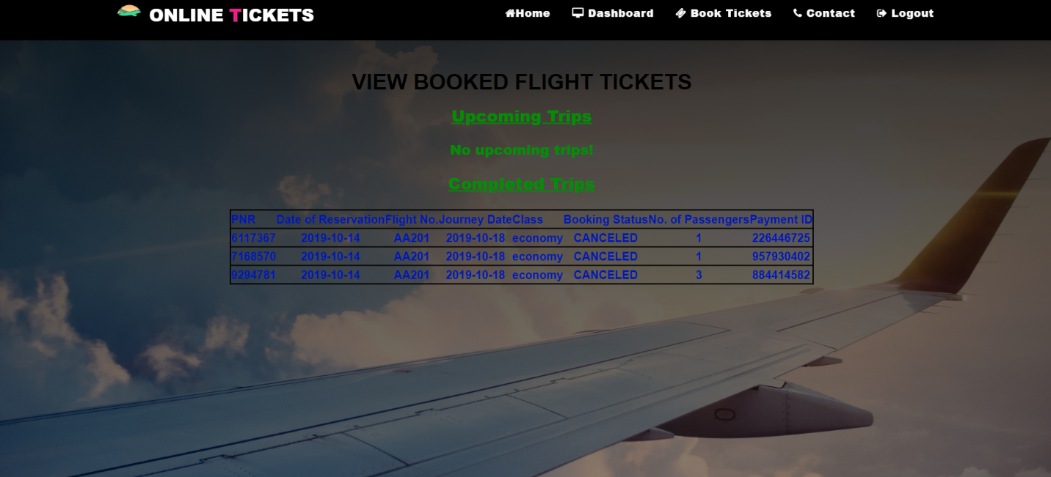

7.3 Add Flight Schedule Details

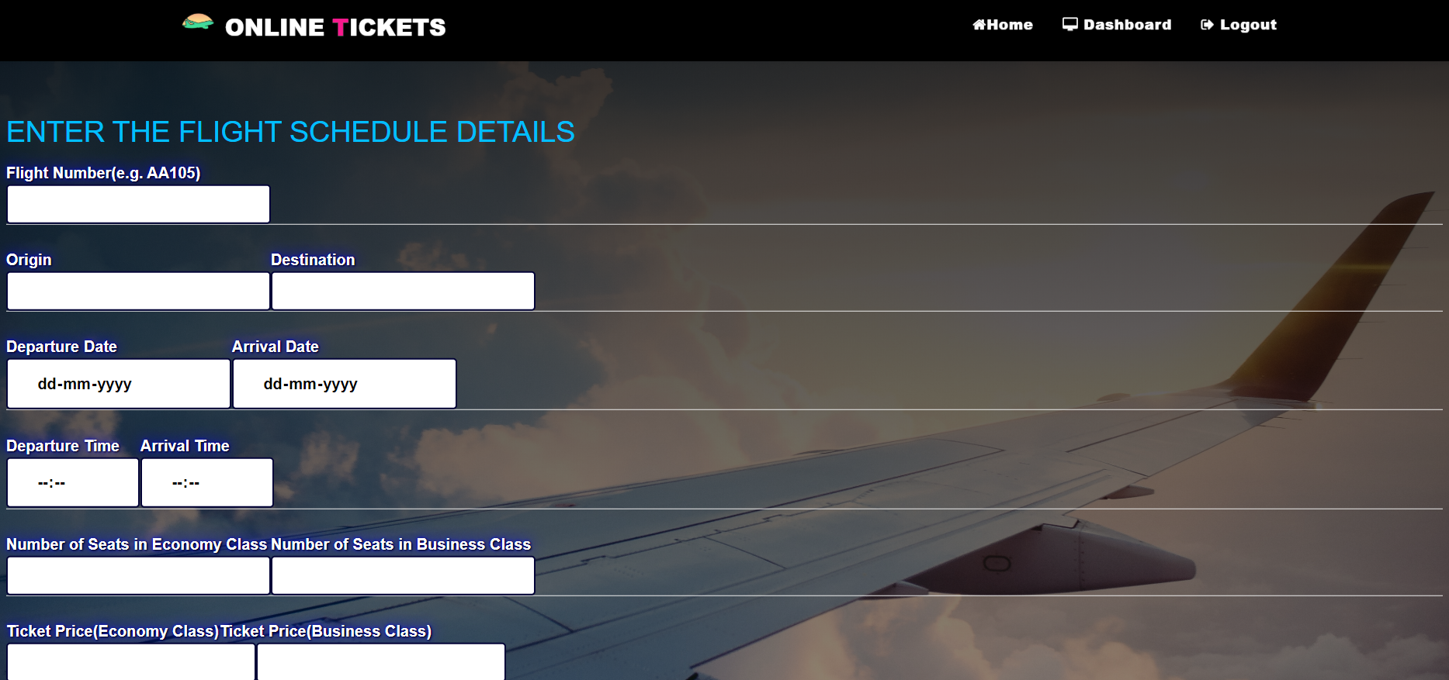

7.4 Available flights

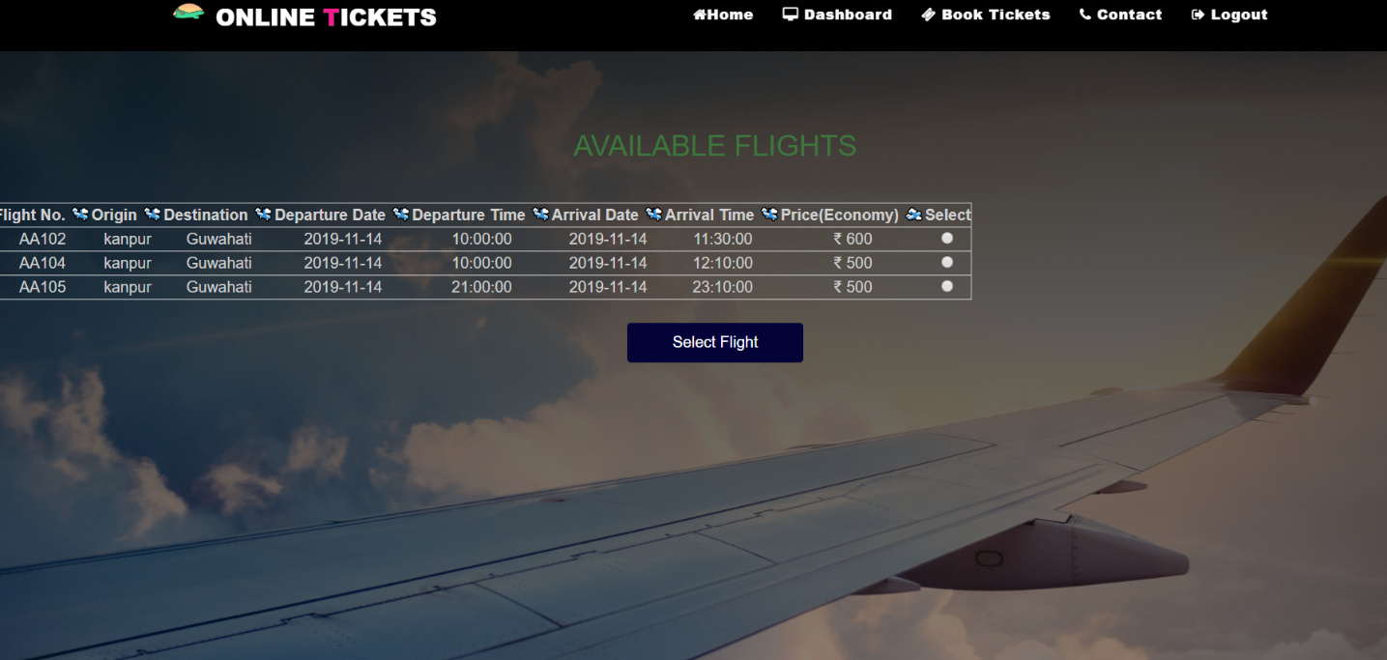

7.5 Add Details

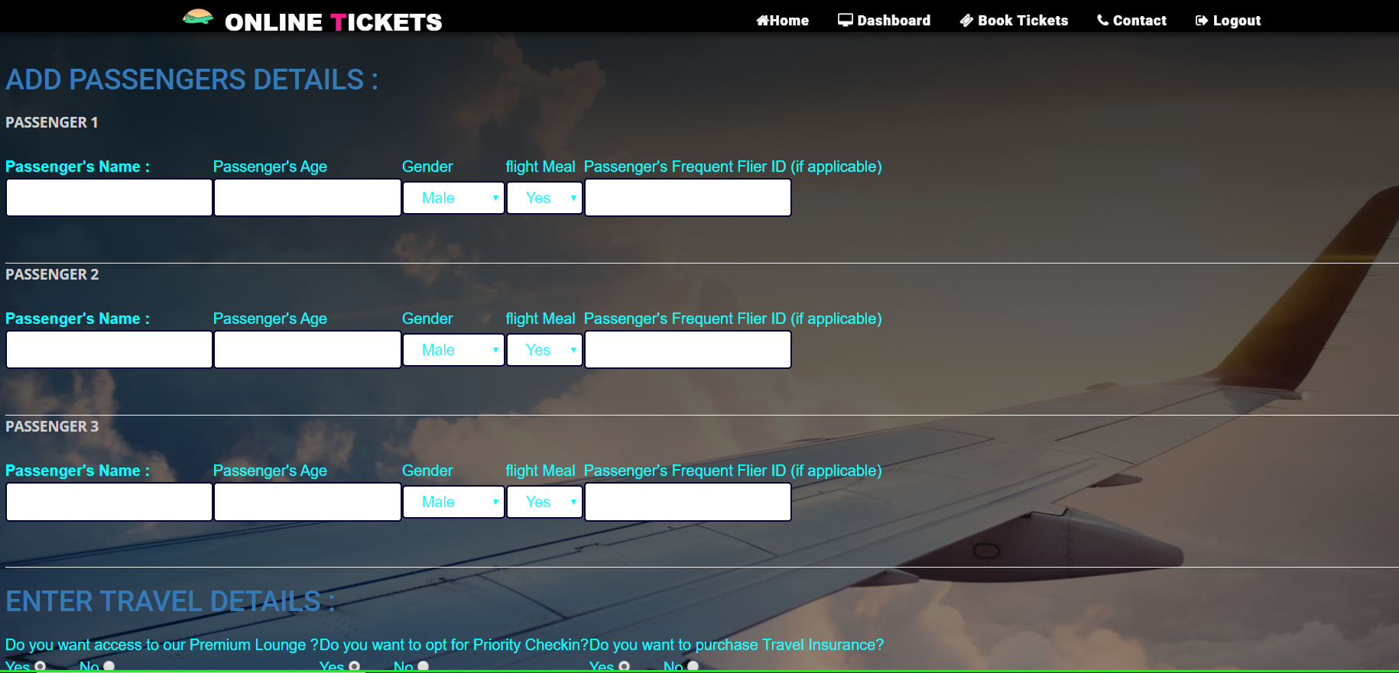

7.6 Payment summary 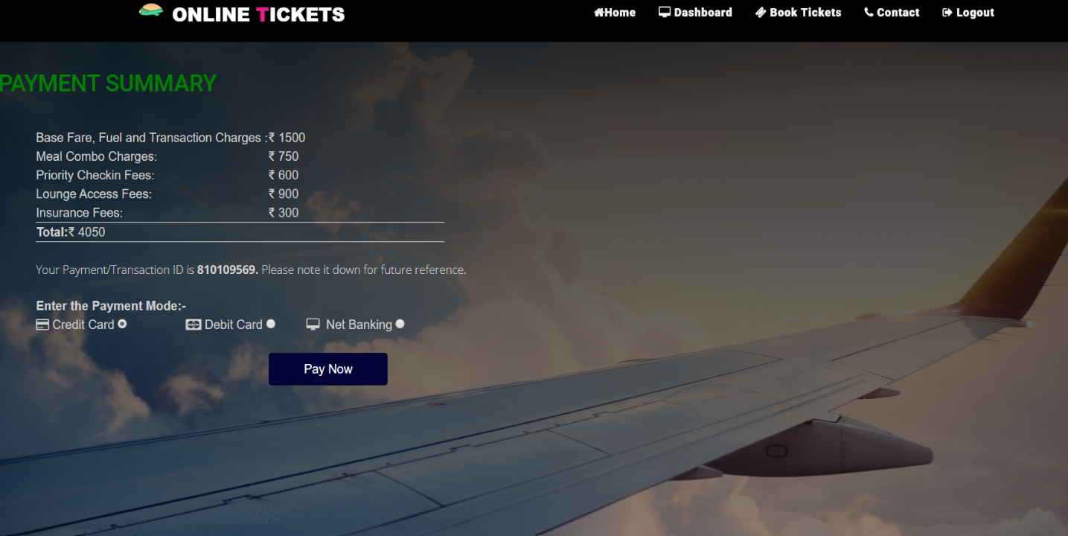

7.7 Booking successful

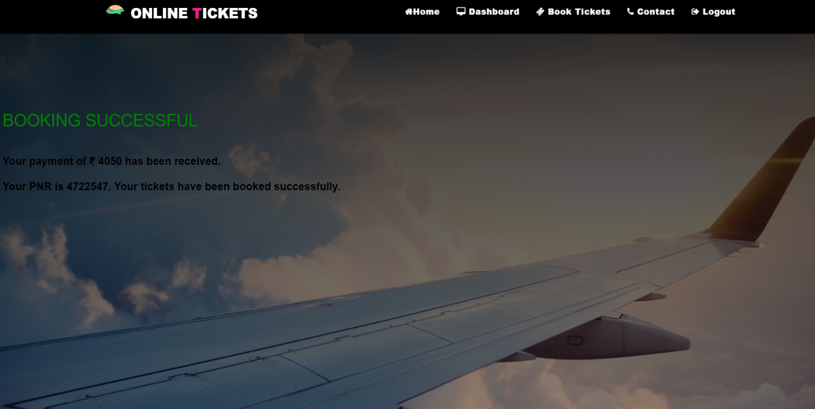

**CHAPTER 8**

CODING



**8.1 Homepage**

<?php

session_start();

?>

<!DOCTYPE html>

<head>

<meta charset="utf-8">

<meta name="viewport" content="width=devidev-width, initial-scale=1.0, maximum-scale=1.0, user-scalable=no">

<meta http-equiv="X-UA-Compatible" content="IE=edge">

<title>Online Ticket Reservation</title>

<!-- [ FONT-AWESOME ICON ] -->

<link rel="stylesheet" type="text/css" href="library/font-awesome-4.3.0/css/font-awesome.min.css">

<!-- [ PLUGIN STYLESHEET ] -->

<link rel="shortcut icon" type="image/x-icon" href="images/icon.png">

<link rel="stylesheet" type="text/css" href="css/animate.css">

<link rel="stylesheet" type="text/css" href="css/owl.carousel.css">

<link rel="stylesheet" type="text/css" href="css/owl.theme.css">

<link rel="stylesheet" type="text/css" href="css/magnific-popup.css">

<!-- [ Boot STYLESHEET ]-->

<link rel="stylesheet" type="text/css" href="library/bootstrap/css/bootstrap-theme.min.css">

<link rel="stylesheet" type="text/css" href="library/bootstrap/css/bootstrap.css">

<!-- [ DEFAULT STYLESHEET ] -->

<link rel="stylesheet" type="text/css" href="css/style.css">

<link rel="stylesheet" type="text/css" href="css/responsive.css">

<link rel="stylesheet" type="text/css" href="css/color/rose.css">

</head>

<body >

<!-- [ LOADERs ] -->

<div class="preloader">

<div class="loader theme_background_color"

<span></span>

</div>

</div>

<!-- [ /PRELOADER ]-->

<!-- [WRAPPER ] -->

<div class="wrapper">

<!-- [NAV] -->

<!-- Navigation -->

<nav class=" nim-menu navbar navbar-default navbar-fixed-top">

<div class="container">

<!-- Brand and toggle get grouped for better mobile display -->

<div class="navbar-header">

<button type="button" class="navbar-toggle collapsed" data-toggle="collapse" data-target="#bs-example-navbar-collapse-1">

<span class="sr-only">Toggle navigation</span>

<span class="icon-bar"></span>

<span class="icon-bar"></span>

<span class="icon-bar"></span>

</button>

<a href=""><img class="logo" src="images/shutterstock_22.jpg"/> </a>

<a class="navbar-brand" href="index.php">Online<span class="themecolor"> T</span>ickets</a>

</div>

<!-- Collect the nav links, forms, and other content for toggling -->

<div class="collapse navbar-collapse" id="bs-example-navbar-collapse-1">

<ul class="nav navbar-nav navbar-right">

<li><a href="index.php" class="page-scroll"><h3><i class="fa fa-home" aria-hidden="true"></i>Home</h3></a></li>

<li>

<?php

if(isset($_SESSION['login_user'])&&$_SESSION['user_type']=='Customer')

{

echo "<h3><a href=\"book_tickets.php\"><i class=\"fa fa-ticket\" aria-hidden=\"true\"></i> Book Tickets</h3></a>";

}

else if(isset($_SESSION['login_user'])&&$_SESSION['user_type']=='Administrator')

{

echo "<a href=\"admin_ticket_message.php\"><h3><i class=\"fa fa-ticket\" aria-hidden=\"true\"></i> Book Tickets</h3></a>";

}

else

{

echo "<a href=\"login_page.php\"><h3><i class=\"fa fa-ticket\" aria-hidden=\"true\"></i> Book Tickets</h3></a>";

}

?>

</li>

<li><a href="#three" class="page-scroll"><h3><i class="fa fa-plane" aria-hidden="true"></i> Services</h3></a></li>

<li><a href="#eight" class="page-scroll"><h3><i class="fa fa-phone" aria-hidden="true"></i> Contact</h3></a></li>

<li>

<?php

if(isset($_SESSION['login_user'])&&$_SESSION['user_type']=='Customer')

{

echo "<a href=\"customer_homepage.php\"><h3><i class=\"fa fa-sign-in\" aria-hidden=\"true\"></i> Login</h3></a>";

}

else if(isset($_SESSION['login_user'])&&$_SESSION['user_type']=='Administrator')

{

echo "<a href=\"admin_homepage.php\"><h3><i class=\"fa fa-sign-in\" aria-hidden=\"true\"></i> Login</h3></a>";

}

else

{

echo "<a href=\"login_page.php\"><h3><i class=\"fa fa-sign-in\" aria-hidden=\"true\"></i> Login</h3></a>";

}

?>

</li>

</ul>

</div>

<!-- /.navbar-collapse -->

</div><!-- /.container-fluid -->

</nav>

<!-- [/NAV]-->

<!-- [/MAIN-HEADING]-->

<section class="main-heading" >

<div class="overlay">

<div class="container">

<div class="row">

<div class="main-heading-content col-md-12 col-sm-12 text-center">

<h1 class="main-heading-title"><span class="main-element themecolor" data-elements=" Airline Ticket, Airline Ticket, Airline Ticket"></span></h1>

<h1 class="main-heading-title"><span class="main-element themecolor" data-elements=" Reservation System, Reservation System, Reservation System"></span></h1>

<p class="main-heading-text adddi"><br>WELCOME TO,<br/>AIRLINE RESERVATION SYSTEM</p>

<?php

if(isset($_SESSION['login_user'])&&$_SESSION['user_type']=='Customer')

{

echo "<a href=\"book_tickets.php\" ><i class=\"fa fa-ticket border2\" aria-hidden=\"true\"></i> <span class=\"border3\">Book Tickets</span></a>";

}

else if(isset($_SESSION['login_user'])&&$_SESSION['user_type']=='Administrator')

{

echo "<a href=\"admin_ticket_message.php\" ><i class=\"fa fa-ticket border2\" aria-hidden=\"true\"></i> Book Tickets</a>";

}

else

{

echo "<a href=\"login_page.php\" ><i class=\"fa fa-ticket border2\" aria-hidden=\"true\"></i> Book Tickets</a>";

}

?>

</div>

</div>

</div>

</div>

</section>

<section class="main-heading" id="home">

<div class="overlay">

<div class="container">

<div class="row">

<div class="main-heading-content col-md-12 col-sm-12 text-center">

<h1 class="main-heading-title">We are Creative</h1>

<p class="main-heading-text">Airline Reservation System will hold flight schedules and its fare tariffs, passenger reservations and ticket records. It saves time as it allows online procedure as users no longer to wait in a queue to book the flights. <br/> It is automatically generated by the server.

Admin is the main authority who can do addition, deletion, and modification of flights if required.

</p>

<div class="btn-bar">

<!---<a href="#" class="btn btn-custom theme_background_color"></a>-->

<a href="#eight" class="btn btn-custom-outline">Contact Us</a>

</div>

</div>

</div>

</div>

</div>

</section>

<!-- [/MAIN-HEADING]-->

<!-- [ DEFAULT SCRIPT ] -->

<script src="library/modernizr.custom.97074.js"></script>

<script src="library/jquery-1.11.3.min.js"></script>

<script src="library/bootstrap/js/bootstrap.js"></script>

<script type="text/javascript" src="js/jquery.easing.1.3.js"></script>

<!-- [ PLUGIN SCRIPT ] -->

<script src="library/vegas/vegas.min.js"></script>

<script src="js/plugins.js"></script>

<!-- [ TYPING SCRIPT ] -->

<script src="js/typed.js"></script>

<!-- [ COUNT SCRIPT ] -->

<script src="js/fappear.js"></script>

<script src="js/jquery.countTo.js"></script>

<!-- [ SLIDER SCRIPT ] -->

<script src="js/owl.carousel.js"></script>

<script src="js/jquery.magnific-popup.min.js" type="text/javascript"></script>

<script type="text/javascript" src="js/SmoothScroll.js"></script>

<!-- [ COMMON SCRIPT ] -->

<script src="js/common.js"></script>

</body>

</html>

**8.2 Login Handler**

<html>

<head>

<title>Login Handler</title>

</head>

<body>

<?php

session_start();

session_destroy();

session_start();

if(isset($_POST['Login']))

{

$data_missing=array();

if(empty($_POST['username']))

{

$data_missing[]='Username';

}

else

{

$user_name=trim($_POST['username']);

}

if(empty($_POST['password']))

{

$data_missing[]='Password';

}

else

{

$pass_word=$_POST['password'];

}

if(empty($_POST['user_type']))

{

$data_missing[]='User Type';

}

else

{

$user_type=$_POST['user_type'];

$_SESSION['user_type']=$user_type;

}

if(empty($data_missing))

{

if($user_type=='Customer')

{

require_once('Database Connection file/mysqli_connect.php');

$query="SELECT count(*) FROM Customer where customer_id=? and pwd=?";

$stmt=mysqli_prepare($dbc,$query);

mysqli_stmt_bind_param($stmt,"ss",$user_name,$pass_word);

mysqli_stmt_execute($stmt);

mysqli_stmt_bind_result($stmt,$cnt);

mysqli_stmt_fetch($stmt);

mysqli_stmt_close($stmt);

mysqli_close($dbc);

if($cnt==1)

{

echo "Logged in <br>";

$_SESSION['login_user']=$user_name;

echo $_SESSION['login_user']." is logged in";

header("location: customer_homepage.php");

}

else

{

echo "Login Error";

session_destroy();

header('location:login_page.php?msg=failed');

}

}

else if($user_type=='Administrator')

{

require_once('Database Connection file/mysqli_connect.php');

$query="SELECT count(*) FROM Admin where admin_id=? and pwd=?";

$stmt=mysqli_prepare($dbc,$query);

mysqli_stmt_bind_param($stmt,"ss",$user_name,$pass_word);

mysqli_stmt_execute($stmt);

mysqli_stmt_bind_result($stmt,$cnt);

mysqli_stmt_fetch($stmt);

mysqli_stmt_close($stmt);

mysqli_close($dbc);

if($cnt==1)

{

echo "Logged in <br>";

$_SESSION['login_user']=$user_name;

echo $_SESSION['login_user']." is logged in";

header('location:admin_homepage.php');

}

else

{

echo "Login Error";

session_destroy();

header('location:login_page.php?msg=failed');

}

}

}

else

{

echo "The following data fields were empty<br>";

foreach($data_missing as $missing)

{

echo $missing ."<br>";

}

}

}

else

echo "Submit request not received";

?>

</body>

</html>

**8.3 Delete Flight details**

<?php

session_start();

?>

<html>

<head>

<title>Delete Flight Schedule Details</title>

</head>

<body>

<?php

if(isset($_POST['Delete']))

{

$data_missing=array();

if(empty($_POST['flight_no']))

{

$data_missing[]='Flight No.';

}

else

{

$flight_no=trim($_POST['flight_no']);

}

if(empty($_POST['departure_date']))

{

$data_missing[]='Departure Date';

}

else

{

$departure_date=trim($_POST['departure_date']);

}

if(empty($data_missing))

{

require_once('Database Connection file/mysqli_connect.php');

$query="DELETE FROM Flight_Details WHERE flight_no=? AND departure_date=?";

$stmt=mysqli_prepare($dbc,$query);

mysqli_stmt_bind_param($stmt,"ss",$flight_no,$departure_date);

mysqli_stmt_execute($stmt);

$affected_rows=mysqli_stmt_affected_rows($stmt);

//echo $affected_rows."<br>";

// mysqli_stmt_bind_result($stmt,$cnt);

// mysqli_stmt_fetch($stmt);

// echo $cnt;

mysqli_stmt_close($stmt);

mysqli_close($dbc);

/*

$response=@mysqli_query($dbc,$query);

*/

if($affected_rows==1)

{

echo "Successfully Deleted";

header("location: delete_flight_details.php?msg=success");

}

else

{

echo "Submit Error";

echo mysqli_error();

header("location: delete_flight_details.php?msg=failed");

}

}

else

{

echo "The following data fields were empty! <br>";

foreach($data_missing as $missing)

{

echo $missing ."<br>";

}

}

}

else

{

echo "Delete request not received";

}

?>

</body>

</html>

**CHAPTER 9**

PROJECT LIMITATION AND FUTURE SCOPE



9.1 Performance Requirement

This subsection specifies numerical requirements placed on the software or on the human

interaction with the software, as a whole. Numerical requirements will include:

➢ 300 terminals will be supported at a time

➢ Only text information will be supported(HTTP)

Proposed projects are beneficial only if they can be turned out into information system.

That will meet the organization’s operating requirements. Operational feasibility aspects

of the project are to be taken as an important part of the project implementation. Some of

the important issues raised are to test the operational feasibility of a project includes the

following:

* sufficient support for the management from the users
* system will be used and work properly if it is being developed and
* implemented time to time.
* There will be some resistance from the user that will undermine the possible
* application benefits.

This system is targeted to be in accordance with the above-mentioned several issues.

there is no question of resistance from the users that can undermine

the possible application benefits.

9.2 Future Scope

The Online Airline Reservation system is the next generation address book which will

provide these two basic services like portability, security.

The future scope includes expand the technologies like HTML and PHP we can

also add new technologies like HTML, php many more for improving the efficiency of

the software.

The project will be useful for any schools and colleges with slightly modification.

Project is flexible i.e. any change /modification in database may be performing easily.

Also this project could be made web enabled.

**Assumptions:**

The user is familiar with basic computer components and operations.

**Dependencies:**

The system should work on all systems.

**CHAPTER 10**

REFERENCES



10.1 Source **:-**

* Software Requirement Specifications from Internet.
* Software Requirement Specifications, Airline Reservation System.
* Php documentation.
* Mysql basics .
* www.slideshare.com
* www.w3school.com
* www.google.com
* www.wikipedia.com
* HTML for the World Wide Web with XHTML and CSS Guide, Fifth Edition
* IEEE Computer Society, 1998.